PART A Expected deliverables:
Website specifications
Objectives and goals
- Providing information on dogs and events held
- Help people identify dog breeds
- Create and build a community of dog enthusiasts
- Provide information on dog care and responsibilities
- Share and create entertaining content on dog events
State the target audience showing their demographics and technical amplitude
- Dog owners
Demographics
- age 13 and above
- location urban and sub urban areas
- lifestyle active, family orientated and pet friendly
Technical aptitude
- Comfortable and willing to use website and apps online
- Knowledge and familiarity with using online platforms to search for pet info
- Capable of using digital devices

b) Kids and teens who love dogs
Demographics
- Age 8 to 18
- Location anywhere
- Education primary to senior school
- Interests like dog facts, dog games, dog events
Technical aptitude
- Ability to use websites
- Enjoys consuming interactive content
- Can use simple navigation

c) Future dog owners
Demographics
- Age 16 and above
- Life stage student, first time dog owners
- Motivation curiosity on dog care and health before adopting
Technical Aptitude
- Can navigate through online sources and guide
- May need easy to understand explanations on information regarding dogs
d) Dog Enthusiasts and hobbyists
Demographics
- ages all ages
- interests dog sports, dog shows, dog breeds, dog health care
Technical Aptitude
- Interest on online information about dogs
- Ability to use websites at an intermediate level

Type Of Website
The Crufts dog club website is a website that is going to bring people together so it is categorised as informative and community website because it brings people together by informing them about the event held and what will be taking place in our club.

SITE MAP:
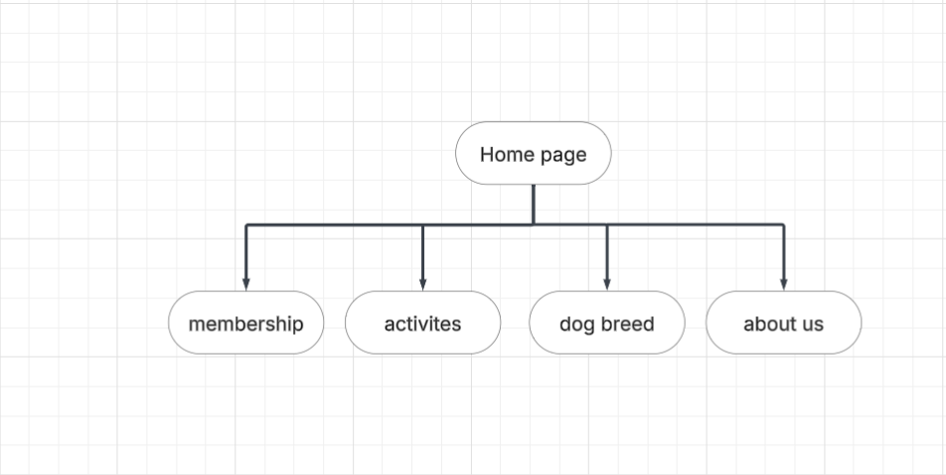

Information Architecture
The website focuses on providing dog related content and information through a different page categorises and creating a community for members to join to help user join and to help users find out about there required needs.
Webpages available:
- Home introduces the club to users
- Membership it keeps users are of the information on role and a join membership button
- Activates shows users events and what we do in the dog club
- Dog breed section shows users common dog breeds suitable for training
- About us more detailed info about the club itself
CONTENT TAXONOMY
Webpages are built using basic web technologies that ensure broad compatibility and easy maintenance. I decided to use core technologies not frameworks since I wanted to display solid understanding of principals which are important for first years to learning and gain knowledge on applying these skills tools and software use include:
- HTML5
- JAVASCRIPT
- CSS3
SOFTWARE TOOLS AND RESOURCES USED TO DEVELOP THE WEBSITE
I only used 3 tools to develop the webpage and test the website. These tools were selected based on KB and TG is recommendations
Visual Studio Code: Primary code editor for writing HTML, CSS, and JavaScript files with syntax highlighting and live preview
GitHub/GitHub Pages: Version control and free web hosting for the live website deployment
Git: Version control system for tracking changes and collaboration
AI Image Generation and editing tools: Creating professional service images and project portfolio images e.g. Gemini and grok

